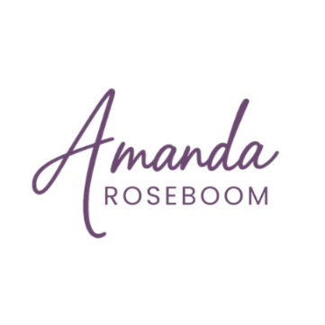
Learning Needs Analysis Template
This Learning Needs Analysis Template is designed to help you assess what your people need to perform their best, and how learning can support that. Whether you're working in instructional design, HR, or training delivery, this tool walks you step-by-step through the key elements of a learning needs analysis so that your solutions are aligned, effective, and actionable.
What’s Inside
Use this template to guide conversations, collect relevant insights, and build a strong foundation for targeted learning strategies.
- Organizational Description: Capture the broader business goals and what success looks like.
- Learning Objectives: Clarify the purpose and measurable outcomes of the learning experience.
- Audience Analysis: Define your learners: roles, levels, tenure, and what they need to succeed.
- Performance Analysis: Understand what people are doing now versus what they need to do.
- Behavior Analysis: Identify behavior shifts needed for performance improvement.
- Skills & Attitudes: Explore current strengths, gaps, and growth areas.
- Training Resources: Inventory what’s available and what’s missing.
- Gap Analysis: Compare perspectives across roles and levels to spot key gaps.
- Learning Strategies: Map out the instructional approach and methods.
- Recommended Interventions: Suggest practical solutions, not just training, that address root causes.
Created by Amanda Roseboom, an experienced instructional designer focused on helping organizations connect learning to real business results.
amanda.roseboom.design@gmail.com
www.amandaroseboom.com
https://www.linkedin.com/in/amandaroseboom/

Learning Needs Analysis
[COMPANY]

Organizational Description
Provide a description – what are the key organizational goals and objectives?

Learning Objectives
What is the primary purpose of the learning experience? What problems are you trying to solve?

Audience Analysis
Primary Audience:
Role Level/Title:
Tenure:

Secondary Audience:
Role Level/Title:
Tenure:

Performance Analysis
What skills and competencies are needed to meet the organizational goals? What skills does the organization need to have in the future? What behaviors, skills, and attitudes need to change?

Behavior Analysis
Behavior | Current Behavior | Desired Behavior | Change Needed

Skills Analysis
Skill | Current Skills | Desired Skill Level | Change Needed

Attitude Analysis
Attitude | Current Attitude | Desired Attitude | Change Needed

Current Training and Resources
What learning and performance improvement resources already exist?

Gap Analysis
Comparison of Current Management and Senior Leadership Perspectives
Key Competencies
Competency | Managers' Perspective | Senior Leadership Perspective | Gaps and Misalignments

Learning Strategies and Methods
What is the overall instructional approach and learning methodology?

Recommended Interventions
Training Recommendations

Non-Training Recommendations

